Data Collection, Reporting, and Financial Incentive
Guidance Document for MORE Care Participants
Thank you for participating in the MORE Care Alternative Payment Model (APM) and data collection process. We are excited to work with you. This packet gives describes the incentive based APM and includes an outline of what data will be collected, reporting periods, as well as how to set-up and transfer data.

Table of Contents
Overview 2
Program Data Contacts 2
Alternative Payment Model 2
Data Cycle 3
Quality Metrics 4
Performance Periods 5
Data Transfer Set-Up Instructions 5
Performance Incentive Payout 7
Appendix 8
Appendix A: Quality Metrics 8
Appendix B: Data & Incentive Schedule 15

Overview
Program Data Contacts
The individuals listed below from the CareQuest Institute for Oral Health will be your contacts during the program entire data process. Please contact them via email when you have questions regarding the data process, respective to each of their roles below.

Dustin Holloway, MPH | Database Developer
Dustin will ensure your data is collected in the proper format and meets quality standards for ingestion. Contact him if you have question about data extraction and transfer.
Email: DHolloway@carequest.org

Adrianna Sonnek, MPH | Research Analyst
Adrianna will ensure comfort with the quality measure and your performance in the payment model as the program progresses. Contact her if you have questions about quality measure or performance dashboards.
Email: ASonnek@carequest.org

Alternative Payment Model Overview
To evaluate how integrated care pathways function, how access, prevention, and outcomes can improve, and to maintain provider engagement, the MORE Care curriculum and provider education will be accompanied by a value-based reimbursement design. The intended design is a fee for service (FFS) + incentive alternative payment model (APM). Participating medical and dental practices will receive normal reimbursement for claims associated with covered procedures rendered to eligible patients within the program while additional allocated dollars from public and commercial payors will cover incentives tied to performance goals of program metrics reported on by practices. Incentive dollars will be rewarded to practices by a fiscal intermediary (Health Path) based on timeliness and quality of reported data (pay-for-reporting) and performance of program metrics against set benchmarks (pay-for-performance). The APM will serve as a testing ground for how the integrated care model can be supported by value-based payment to reward utilization of preventive, risk-based oral health care within primary care and a referral process between dental and primary care practices.

Duration: the APM will span a period of 25 months; the first 12 months will focus on data infrastructure building, curriculum and quality improvement, and practice performance in the APM while the latter 13 months will focus on sustaining changes and improved performance in the APM.

Patient Population: individuals age 0-18 who present for a prenatal, well child or annual adolescent assessment medical visit or a routine, diagnostic, or problem focused dental visit at the participating practices.

Data Cycle
Data collection from each practice and subsequent processing and scoring will be done on a monthly basis. See the monthly data cycle below:

Data collection, processing and incentive payout will operate according to a set schedule. Payouts to qualifying practices by the fiscal intermediary will take place every 4th month during the 25-month program beginning in March 2023, based on performance against set benchmarks for quality measures.

Quality Metrics
Two categories of data will be collected by MORE Care participants including incentivized data, or data that has the potential to be financially rewarded (pay-for-reporting and pay-for-performance) and non-incentivized data that is not included as a part of the financial incentive. Additionally, weights of the pay-for-reporting and pay-for-performance measures will change as the program advances – less weight will be put on pay-for-reporting measures as practices become proficient in data reporting while more weight will be put on pay-for-performance measures as practices gain experience with performing the appropriate oral health services.

Incentivized Data
- Pay-for-Reporting (P4R)
CareQuest Institute has defined a set of data reporting measures in an effort to incentivize practices to report quality data in a timely manner. P4R quality measures are presented in Appendix A.

- Pay-for-Performance (P4P)
CareQuest Institute has defined a set clinical and operational measures for medical and for dental practices. They aim to assess practice performance of prevention-focused, risk-based, integrated and coordinated care and align with the MORE Care curriculum. P4P quality measures are presented in Appendix A.

Non-Incentivized Data
There are a handful of quality metrics that are important to collect because they give insight into practice performance with the incentivized metrics but are not included in the financial incentive. Non-incentivized quality measures are also presented in Appendix A.

The data will include suggested CDT codes listed in the table in Appendix A. The suggested format to send the data to CareQuest Institute can be found in the MORE Care resource library on the Community Hub for both medical and dental practices. CareQuest Institute data contacts will help you align your health or dental record data with the intended reporting structure at the beginning of the MORE Care program.

Performance Periods
Practice reporting and performance periods for all incentivized and non-incentivized data will begin in November 2022 and end October 2024.
Baseline data (November 2021 – October 2022) of all incentivized and non-incentivized metrics will be collected during data onboarding of clinics between October and November 2022.
Subsequent incentivized and non-incentivized data will be collected on a monthly basis. Monthly data reports are due by the end of each month.
See Appendix B for the full data reporting schedule.

Data Transfer Set-up and Instructions
Below is a step-by-step guide to set up data transfer capabilities and then how to complete file transfers.
Setting up:
How to Transfer Files:
1. Download FileZilla Client onto your computer: Make sure you download FileZilla Client (see the blue arrow below), not FileZilla Server. https://filezilla-project.org/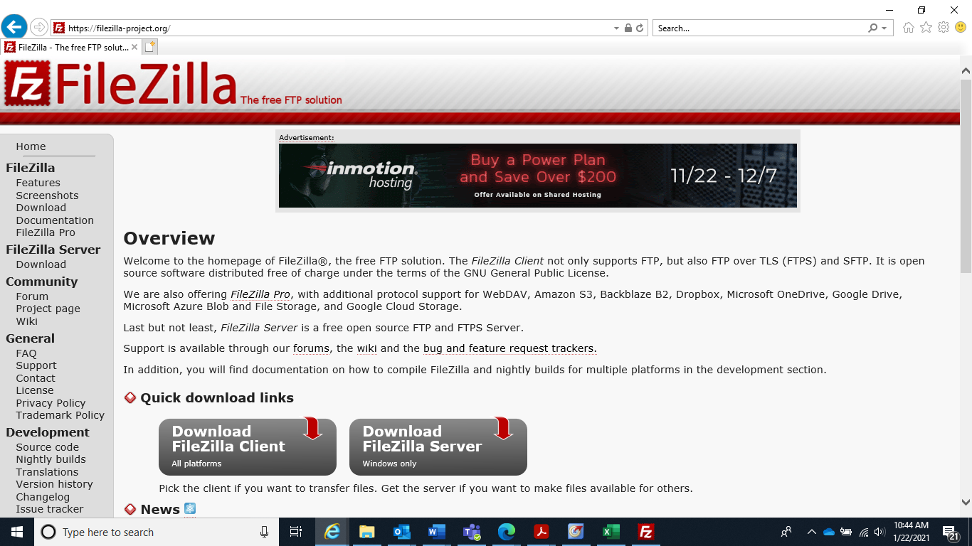

2. Okta Verify: A link will be sent to you from Okta to activate your account (noreply@okta.com). We have already set up your username to be your email address. You will set your own password. If you have not received this email), please reach out to Dustin Holloway (DHolloway@carequest.org).
Example of the email you will receive: 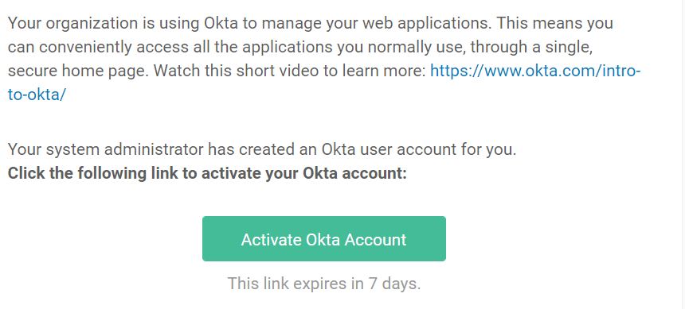
  - Click the link to activate your account and set your password. You will use this information in FileZilla in the next step.

- Once you have FileZilla downloaded and Okta account set up, open the FileZilla program.
- At the top of the program you should see the following:
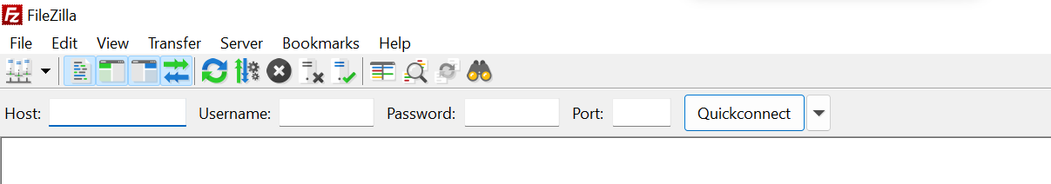

Enter the following:
Host: s-de9e35e1a24f4a61a.server.transfer.us-east-1.amazonaws.com
Username: your email address used to log-in to Okta
Password: the password you set up in Okta
Port: 22
Then hit QuickConnect.
- From there you should see a folder that says “enterprise-initiative-more-care” and then below it a folder with your email address. This folder is where you will drag your files into. It is a secure folder that only you have access to.
On the left you will see the folders on your computer where you can select your file, and then drag it into the folder with your name on the right. Once you drag it over, you should see it appear in the Filename area (ex: Data Collection Techni… below).
*If you want to delete the file you uploaded, you can right click on it and choose Delete.
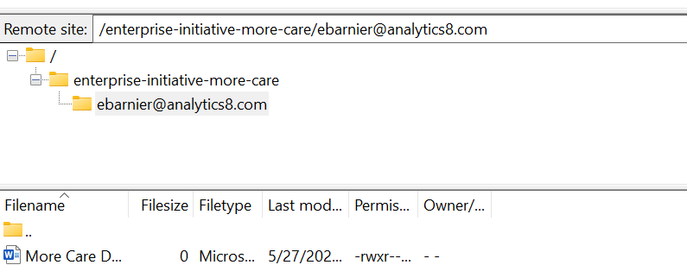

Performance and Incentive Payout
After you have submitted your practice’s data by the end of the second week of each month, CareQuest Institute will evaluate your performance against set benchmarks for the incentivized quality metrics. Subsequently, your performance data will be returned to your practice during the last week of each month for use in the quality improvement process and to understand qualification for incentive payout. Your quality metric performance will be displayed in the form of a digital Participant Data Dashboard, as seen below. The dashboard will display counts of each incentivized and non-incentivized quality metric. Additionally, for each incentivized metric you will also receive a number score based on your clinic performance against the set benchmark. This score will be an indicator of qualification for an incentive payout in the alternative payment model.

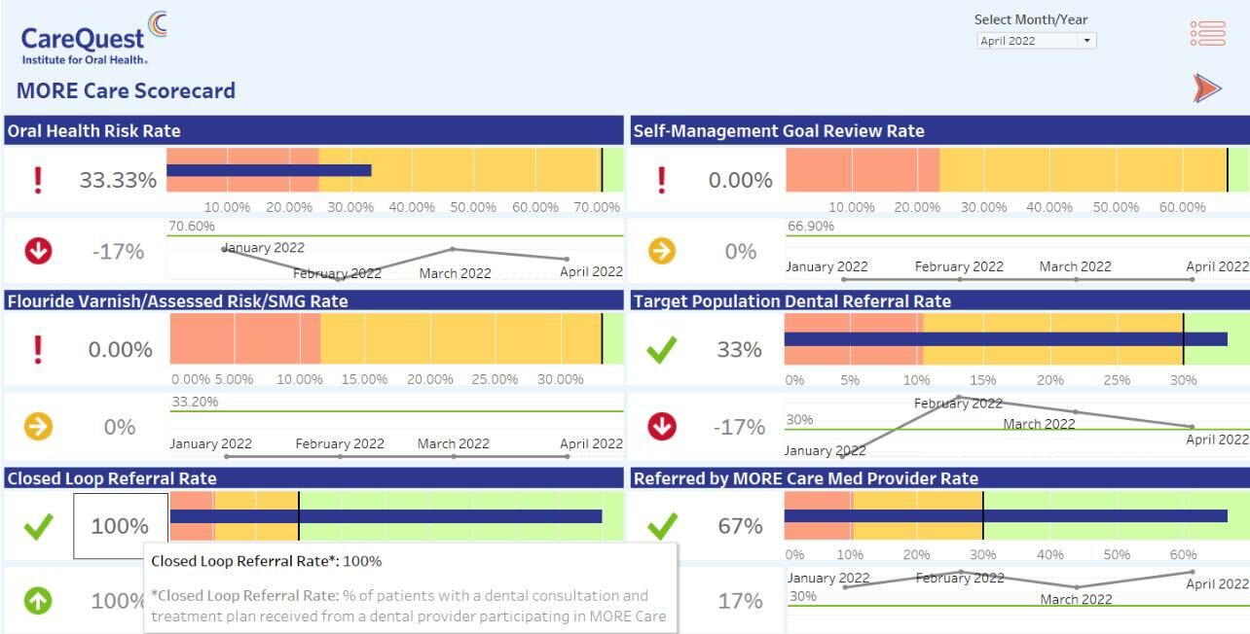

Payouts to qualifying practices by a fiscal intermediary will take place every 4th month during the 25-month program beginning in March 2023 based on the previous 3 months of performance. See Appendix B for data dashboard delivery to practices and performance payout schedule.

Appendix A: Quality Metrics
Frequency:
- All incentivized and non-incentivized quality metrics for medical and dental practices will be collected and reported at the beginning of the program (baseline), and on a monthly basis by the end of the second full week of the month, for the previous months data.
Data Submission:
- Clinics will extract data from their EHR/PMS based in the codes listed in the table below with corresponding patient level, appointment level, or claim or encounter level.
- Please see the EHR/PMS Data Template in the MORE Care Resource Library for an example of what the data report for extraction should look like.
- It is not intended that each clinic will be actively using and tracking all the CDT codes that make up the quality metrics below and some counts may be zero. The purpose of reporting on all the CDT codes below is so participants can track progress with clinical changes made during the learning community.
Note: pay attention to the “audience” column to understand which metrics are intended for medical practices only, dental practices only, or both.

Incentivized Data
- Pay-for-Reporting (P4R) metrics:
Metric | Numerator [ tier (% of dollars earned) ] | Denominator | Incentive Weight | Audience
Completeness of reported data | Total number of required data fields submitted within the agreed upon timeframe according to thresholds:  - 100% of required data (100%)  - 50-99% of required data (90%)  - 1-49% of required data (80%)  - 0% of required data (0%) | Total number of required data fields | 33.33% | Medical and dental partner
Quality of reported data | Total number of required data fields submitted during a reporting timeframe based on the established format and baseline data extraction:  -100% quality - there are no deviations or inconsistency issues with data extraction (100%)  0% quality - any deviation or inconsistency without notifying CareQuest Institute of anticipated changes at least two weeks prior to submission (90%) | Total number of required data fields | 33.33% | Medical and dental partner
Completeness of reported demographic data | Total number of required data fields submitted during a reporting timeframe based on the established format and baseline data extraction:  - 100% of required data (100%)  - 75-99% of required data (95%)  - 50-74% of required data (90%)  - 25-49% of required data (85%)  - 1-24% of required data (80%)  - 0% of required data (0%) | Total number of required data fields | 33.33% | Medical and dental partner

- Pay-for-Performance metrics:
Metric | Numerator | Denominator | Audience
% of patients with documented oral health risk | Total number of the following codes recorded during the measurement period: 99188, D0191, or Z01.2 | The total number of encounters identifying that services were provided during a well child or pre-natal or adolescent routine visit during the measurement period | Medical partner
% of patients with oral health self-management goals reviewed | Total number of the following codes recorded during the measurement period: Z71.89, D1310, D1320, D1330 | The total number of encounters identifying that services were provided during a well child or pre-natal or adolescent routine visit during the measurement period | Medical partner
% of patients with documented fluoride varnish application in conjunction with assessed risk and SMG reviewed | Total number of the following codes recorded during the measurement period: Z29.3 or 99188 in conjunction with assessed risk and self-management goal review | The total number of encounters identifying that services were provided during a well child or pre-natal or adolescent routine visit during the measurement period | Medical partner
% of patients in the target  population that were referred to a dental provider participating in MORE Care | Total number of referrals to a MORE Care participating medical provider during the measurement period, may be indicated by: SNOmed 103697008 | The total number of encounters identifying that services were provided during a well child or pre-natal or adolescent routine visit during the measurement period | Medical partner
% of patients with dental consultation and treatment plan received from dental provider participating in MORE Care (closed loop referrals) | Total number of dental consultation and treatment plan received from dental partner, closing the referral loop closed by medical provider within 3 months of referral initiation during the reporting period. May be indicated by SNOmed 34043003 | The total number of encounters identifying that services were provided during a well child or pre-natal or adolescent routine visit during the measurement period | Medical partner
% of patients referred by a MORE Care participating medical provider with a dental consultation treatment plan received | Total number of referrals by a MORE Care participating medical provider with a dental consultation and treatment plan received during the measurement period | The total number of procedure codes identifying that oral health services were provided during the measurement period | Dental partner
% of caries risk assessments complete | Total number of patients with the following codes recorded during the measurement period: D0601, D0602, D0603 or Z91.8 codes | The total number of patients, new (D0150) or established (D0120), due for a caries risk assessment during the measurement period | Dental partner
Surgical  Intervention Rate | Total number of the following codes recorded during the measurement period:  - Minor Restorative: D2140, D2150, D2160, D2161, D2330, D2331, D2332, D2335, D2391, D2392, D2393, D2394, D2410, D2420, D2430, D2930, D2931, D2928, D2929, D2933, D2934, D2932  - Major Restorative: D2510, D2520, D2530, D2542, D2534, D2544, D2610, D2620, D2620, D2630, D2642, D2634, D2644, D2650, D2651, D2652, D2662, D2663, D2664, D2710, D2712, D2720, D2721, D2722, D2740, D2750, D2751, D2752, D2753, D2780, D2781, D2782, D2783, D2790, D2791, D2792, D2794, D2390, D2949, D2950  - Endodontic: D3110, D3220, D3221, D3230, D3240, D3310, D3320, D3330, D3331, D3332  - Extraction: D7111, D7210, D7140, D7250 | The total number of procedure codes identifying that oral health services were provided during the measurement period | Dental partner
Primary and secondary prevention intervention rate | Total number of the following codes recorded during the measurement period: D1110, D1120, D1206, D1208, D1351, D1352, D1353, D1354, D1355, D1310, D1320, D1330 | The total number of procedure codes identifying that oral health services were provided during the measurement period | Dental partner

Non-Incentivized Data
Metric | Numerator | Denominator | Audience
% of patients referred to any dental or medical provider | Total number of referrals:  -To any dental provider by a MORE Care participating medical provider identified by SNOmed 103697008  -To any medical provider by a MORE Care participating dental provider identified by manual tracking or dummy code | The total number of procedure codes or encounters identifying that services were provided during a well child, pre-natal, adolescent routine medical visit or dental visit during the measurement period | Medical and dental partner
% of patients with self-management goal of _____  (see SMG categories) | Total number of self-management oral health goals (SMG) that were documented as any of the following categories:  - Dental Visits  - Oral Hygiene  - Diet & Nutrition  - Oral Injury Prevention  (see SMG category examples in MORE Care resource library) | The total number of encounters identifying that services were provided during a well child or pre-natal or adolescent routine visit during the measurement period and documented self-management goals from the encounter note following the CareQuest template | Medical partner
% of emergency visits | Total number of the following codes recorded during the measurement period:  -Dental: D0140, D9110 or dummy code for emergency visit (if used at the practice)  -Medical: Dummy code for emergency visit (if used at the practice) | The total number of procedure codes or encounters identifying that services were provided during a well child, pre-natal, adolescent routine medical visit or dental visit during the measurement period | Medical and dental partner
Annual dental visit | Total patient volume seen at dental practice for an ADV after baseline | Total patient volume seen at dental practice for ADV at baseline | Dental partner
% of appointments that are broken | Total number of the following codes recorded during the measurement period:  -D9986 or D9987 or Dummy code for missed appointment (if used at the practice)  -Total Appointments with a cancelled or no showed status | The total number of procedure codes identifying that oral health services were provided during the measurement period  This would include the sum of kept visits plus no-shows, last minute cancellations minus walk-ins. | Dental partner
Cost of Care | Total cost of care for target population for all medical and dental participating clinics | n/a | Medical and dental partner
Patient race | Number of patients that identify as each race category: American Indian or Alaska Native OR Asian OR Black or African American OR Native Hawaiian or Other Pacific Islander OR White OR a combination of any of the above | Total number of patients who had a well child, pre-natal, adolescent routine visit, or dental visit during the measurement period | Medical and dental partner
Patient ethnicity | % of patients that identify as each ethnicity category: Hispanic or Latino OR Not Hispanic or Latino | Total number of patients who had a well child, pre-natal, adolescent routine visit, or dental visit during the measurement period | Medical and dental partner
Patient DOB | % of patients in each age category: 0-6, 7-10, 11-15, 16-18 | Total number of patients who had a well child, pre-natal, adolescent routine visit, or dental visit during the measurement period | Medical and dental partner
Patient sex at birth | % of patients in each sex category: male OR female | Total number of patients who had a well child, pre-natal, adolescent routine visit, or dental visit during the measurement period | Medical and dental partner
Patient current gender identity | % of patients in each gender identity category: male OR female OR other OR choose not to disclose OR transgender male OR transgender female OR unknown/unreported | Total number of patients who had a well child, pre-natal, adolescent routine visit, or dental visit during the measurement period | Medical and dental partner
Patient sexual orientation | % of patients in each sexual orientation category: bisexual OR heterosexual OR other OR choose not to disclose OR lesbian, gay, or homosexual OR do not know OR unknown/unreported | Total number of patients who had a well child, pre-natal, adolescent routine visit, or dental visit during the measurement period | Medical and dental partner
Patient language barrier | % of patients in each language barrier category: no language barrier OR language barrier OR unknown/unreported | Total number of patients who had a well child, pre-natal, adolescent routine visit, or dental visit during the measurement period | Medical and dental partner
Patient homeless status | % of patients in each homeless status category: at risk of homelessness OR doubling up OR homeless OR homeless/unknown shelter OR not homeless OR shelter OR street OR transitional OR unknown/unreported | Total number of patients who had a well child, pre-natal, adolescent routine visit, or dental visit during the measurement period | Medical and dental partner
Patient family size - FPL Calculation | Total number of family members living in household | Total number of patients who had a well child, pre-natal, adolescent routine visit, or dental visit during the measurement period | Medical and dental partner
Patient family income - FPL Calculation | Total income of family members living in household | Total number of patients who had a well child, pre-natal, adolescent routine visit, or dental visit during the measurement period | Medical and dental partner
Patient federal poverty level | % of patients within each federal poverty level percentage | Total number of patients who had a well child, pre-natal, adolescent routine visit, or dental visit during the measurement period | Medical and dental partner
Patient primary care provider | % of patients in each primary care provider: no primary care provider OR primary care provider | T Total number of patients who had a well child, pre-natal, adolescent routine visit, or dental visit during the measurement period | Medical and dental partner
Insurance status | % of patients in each insurance category: Medicaid insurance OR commercial insurance OR uninsured | Total number of patients who had a well child, pre-natal, adolescent routine visit, or dental visit during the measurement period | Medical and dental partner
Chronic conditions | % of patients in with the following common chronic conditions:  - Asthma (J45)  - Diabetes (E08, E10, E11, E13)  - Obesity or overweight (E66, Z68.53, Z68.54)  - Cystic Fibrosis (E84)  - Developmental disabilities (all F codes)  - Autism spectrum disorders (F840)  - Epilepsy (G40)  - Early Childhood Caries (K02) | Total number of patients who had a well child, pre-natal, adolescent routine visit, or dental visit during the measurement period | Medical and dental partner
Social Determinants of Health | % of patients experiencing the following common social determinants of health (see second link for specific codes):  Z55.* – Problems related to education and literacy  Z56.* – Problems related to employment  and unemployment  Z57.* – Occupational exposure to risk factors  Z59.* – Problems related to housing and  economic circumstances  Z60.* – Problems related to social environment  Z62.* – Problems related to upbringing  Z63.* – Other problems related to primary support  group, including family circumstances  Z64.* – Problems related to certain psychosocial  circumstances  Z65.* – Problems related to other psychosocial  circumstances | Total number of patients who had a well child, pre-natal, adolescent routine visit, or dental visit during the measurement period | Medical and dental partner

Appendix B: Data & Incentive Schedule
The schedule below details monthly reporting periods, due dates of data extractions from each medical and dental practice, delivery date of performance dashboards and scorecards as well as payout dates (for qualifying practices only).

Table Definitions:
- Performance Period – the distinct timeframe in which data is collected and performance for that interval is evaluated (ex. each period for the MORE Care program is one month).
- Data Due Date – the date on which a practice’s data must be transferred to CareQuest Institute according to the agreed upon format.
- Dashboard Delivery – the date on which practices will receive performance data in the form of a participant data dashboard from CareQuest Institute.
- Attribution Date – an indication of the date that payments will be attributed to practices, dependent on qualification.
- Estimated Delivery Date – the estimated date of incentive payout delivery to each practice by HealthPath

Performance Period | Data Due Date | Dashboard Delivery Date | Attribution Date | Estimated Delivery Date
Baseline  (November 2021 – October 2022) | 11/11/22 | None | Data infrastructure building lump sum | Within 30 days following execution of MOU
PAY-FOR-REPORTING (100%) BEGINS
November 2022 | 12/16/22 | None | None | None
December 2022 | 1/13/23 | None | None | None
January 2023 | 2/10/23 | None | None | None
February 2023 | 3/17/23 | 3/31/23 | Payout 1 – 3/31/23 | By 4/30/23
PAY-FOR-REPORTING (75%) / PAY-FOR-PERFORMANCE (25%) BEGINS
March 2023 | 4/14/23 | 4/28/23 | None | None
April 2023 | 5/12/23 | 5/31/23 | None | None
May 2023 | 6/16/23 | 6/30/23 | None | None
PAY-FOR-REPORTING (50%) / PAY-FOR-PERFORMANCE (50%)
June 2023 | 7/14/23 | 7/31/23 | Payout 2 – 7/31/23 | By 8/31/23
July 2023 | 8/11/23 | 8/31/23 | None | None
August 2023 | 9/15/23 | 9/29/23 | None | None
PAY-FOR-REPORTING (25%) / PAY-FOR-PERFORMANCE (75%)
September 2023 | 10/13/23 | 10/31/23 | None | None
October 2023 | 11/17/23 | 11/30/23 | Payout 3 – 11/30/23 | By 12/31/23
November 2023 | 12/15/23 | 12/29/23 | None | None
December 2023 | 1/12/24 | 1/31/24 | None | None
January 2024 | 2/16/24 | 2/29/24 | None | None
February 2024 | 3/15/24 | 3/29/24 | Payout 4 – 3/29/24 | By 4/30/24
March 2024 | 4/12/24 | 4/30/24 | None | None
April 2024 | 5/17/24 | 5/31/24 | None | None
May 2024 | 6/14/24 | 6/28/24 | None | None
June 2024 | 7/12/24 | 7/31/24 | Payout 5 – 7/31/24 | By 8/31/24
July 2024 | 8/16/24 | 8/30/24 | None | None
August 2024 | 9/13/24 | 9/30/24 | None | None
September 2024 | 10/11/24 | 10/31/24 | None | None
October 2024 | 11/11/24 | 11/30/24 | Payout 6 – 11/29/24 | By 12/31/24

